Appendix VI. Supervised ACOS Extractor Training and Held-Out Evaluation Protocol
- Purpose of the supervised extractor
This appendix documents the supervised ACOS extractor used in the framework. The purpose of this stage is to make the text-to-evidence procedure deployable, reproducible, and scalable beyond direct large language model inference. In the proposed measurement framework, the extractor is not treated merely as a predictive model. Rather, it forms part of the measurement instrument because it operationalises a stable mapping from raw review text to admissible ACOS evidence units, each consisting of an aspect, a facet-linked category, an opinion expression, and an ordinal sentiment label.
The extractor preserves the evidence representation defined in the earlier appendices. The permitted category labels are fixed as FOOD#QUALITY, SERVICE#GENERAL, and AMBIENCE#GENERAL, corresponding respectively to perceived food quality, perceived service quality, and perceived environment quality. The sentiment label is restricted to the five ordered categories very negative, negative, neutral, positive, and very positive. The model output is constrained to a JSON list-of-lists format: [[ASPECT, CATEGORY, OPINION, SENTIMENT], ...]
This output format was chosen because it keeps each recovered evidence unit inspectable and directly traceable to the later aggregation stage. The extractor therefore supports scalable measurement while preserving the same evidence contract used during weak labelling and adjudicated gold annotation. This continuity is important because the ACOS unit remains the admissible observation throughout the pipeline: the category label links each evidence unit to a construct facet, and the ordered sentiment label provides the evaluative information required for score construction and interpretation.
- Data inputs, sample separation, and leakage safeguards
The supervised extractor was developed from two distinct supervision streams. The first stream was the weak-labelled ACOS corpus generated through the LLM-assisted coding protocol described in Appendix III. This stream was used to provide broad task coverage and to teach the extractor the structured ACOS output format. The second stream was the adjudicated gold reference set described in Appendix V. This stream was used to calibrate the extractor against the intended coding standard and to estimate final held-out performance. The role of each data source in model fitting, model selection, final performance estimation, and deployment is summarised in Table 1.
To reduce circular validation, data leakage, and selection-induced optimism, we separated the adjudicated reference set into two non-overlapping streams before supervised extractor calibration and final evaluation (Cawley & Talbot, 2010). Figure 1 summarises this split procedure. The figure shows how the frozen adjudicated reference set was first normalised into a consistent ACOS representation, then assigned review-level stratification features, and finally separated into an adjudicated calibration stream and a frozen final hold-out benchmark. This visual workflow is intended to clarify the logic of sample separation before the more detailed procedural description below.
------------------Insert Figure 1 around here------------------
The input to this procedure was the frozen adjudicated reference set, which contained 5,431 review-level records and 15,635 adjudicated ACOS observations. The original reference set was preserved unchanged. For each usable record, the procedure extracted the review identifier, review text, city, and final adjudicated ACOS list, and then constructed diagnostic features from the adjudicated tuples for allocation purposes only. Before splitting, the ACOS representation was normalised to ensure consistency with the downstream measurement pipeline: both list-of-lists and list-of-dictionaries formats were accepted, category and sentiment labels were canonicalised, incomplete tuples were removed, tuples outside the three allowed task categories were excluded, and exact duplicate tuples were deduplicated. This ensured that the split was based on the same closed evidence representation used throughout the study, namely FOOD#QUALITY, SERVICE#GENERAL, and AMBIENCE#GENERAL, combined with the five ordered sentiment labels.
After loading and normalisation, a light-weight stratification key was constructed for each review. This key combined six properties: city, long-review status based on a 40-word threshold, the category signature of the adjudicated ACOS tuples, the sentiment bucket, multifacet status, and tuple-count bucket. The split was therefore not a simple random partition. It was designed to preserve heterogeneity in geography, review length, construct-facet coverage, sentiment composition, multifacet evidence, and evidence density across the adjudicated calibration and held-out benchmark streams.
The target hold-out ratio was set to 0.30, and a fixed random seed was used to make the allocation reproducible. Within each stratum, records were first sorted by review identifier and then shuffled using a deterministic stratum-specific subseed derived from the base seed and stratum key. Approximately 30% of each stratum was assigned to the final hold-out benchmark, while preserving at least one calibration case in strata with two or more observations whenever possible. This design provides reproducibility while reducing the risk that the final benchmark becomes compositionally unrepresentative of the adjudicated reference set.
The procedure produced two substantive data streams for model development and evaluation. The adjudicated calibration stream contained 3,802 reviews and 10,951 adjudicated ACOS observations, and was used only for stage-2 supervised refinement of the extractor. The final held-out benchmark contained 1,629 reviews and 4,684 adjudicated ACOS observations before evaluation-time tuple capping, and was reserved only for final performance estimation. These two streams are shown in Figure 1, while Table 1 places them in the broader pipeline alongside the weak-labelled corpus and the final deployed model outputs.
------------------Insert Table 1 around here------------------
This separation establishes the leakage safeguard used in Step 5. As shown in Table 1, the weak-labelled corpus provides broad stage-1 supervision, the adjudicated training split provides stage-2 calibration to the reference coding standard, and the adjudicated final hold-out remains untouched by prompt refinement, model fitting, checkpoint selection, and post hoc tuning. The final deployed model outputs are generated only after model selection and held-out evaluation have been completed. As a result, final extractor performance is estimated on a frozen adjudicated benchmark that is independent of the data used to train or refine the deployable model.
- Model architecture and output constraints
The extractor was implemented as a sequence-to-sequence text generation model using the Hugging Face Transformers framework (Wolf et al., 2020). The base model was FLAN-T5-large. T5 formulates NLP tasks in a unified text-to-text format, making it suitable for structured generation tasks in which both the input and output are represented as text (Raffel et al., 2020). FLAN-T5 extends the T5 family through instruction fine-tuning, a procedure designed to improve task generalisation by training models on collections of tasks expressed as natural-language instructions (Chung et al., 2024). This architecture was therefore appropriate for the present extractor, where the input consists of a fixed extraction instruction followed by review text, and the output is a structured JSON list of ACOS observations.
The model receives a fixed extraction prompt followed by the review text and generates a JSON list-of-lists in which each inner list represents one ACOS observation. The prompt defines the output format, allowed categories, allowed sentiment labels, evidence admissibility rules, and negative constraints. In particular, the model is instructed not to infer latent scores, not to add tuples merely to cover all three facets, not to generate whole-review summaries, and not to replace local evidence with generic paraphrases unless such wording is explicitly present in the review. These constraints are important because the goal is not broad document-level sentiment classification but the recovery of facet-linked micro-level observations suitable for subsequent measurement. The fixed prompt used for extractor training and evaluation is reported below.

Extract ACOS tuples as a valid JSON list-of-lists.
Output format must be exactly [[ASPECT, CATEGORY, OPINION, SENTIMENT], ...].
Every inner list must contain exactly four double-quoted strings.
Each tuple must be a facet-linked textual observation directly supported by explicit review text.
Treat each ACOS tuple as an admissible micro-level observation rather than a whole-review summary.

Allowed CATEGORY values are exactly FOOD#QUALITY, SERVICE#GENERAL, and AMBIENCE#GENERAL.
Copy one of those category strings exactly; do not invent, vary, or paraphrase category names.

Use FOOD#QUALITY for evaluative evidence about the food consumed, including taste, freshness, temperature, presentation, menu variety, and healthy options when explicitly mentioned.
Use SERVICE#GENERAL for evaluative evidence about employee service during the service encounter, especially attitudes, interpersonal interactions, helpfulness, promptness, and communication with customers.
Use AMBIENCE#GENERAL for evaluative evidence about the restaurant's physical environment, including decor, artifacts, spatial layout, and ambient conditions such as noise, temperature, lighting, and cleanliness.

Sentiment must be one of: very negative, negative, neutral, positive, very positive.
Only output tuples directly supported by explicit text evidence.
Do not infer latent scores, overall restaurant quality, or unstated facet evaluations.
Do not add a tuple just to cover food, service, or ambience.
A review may mention one, two, or three facets.

Prefer the local opinion phrase from the review rather than a generic paraphrase such as very good, nice, or 5/5 unless those exact words appear.
If the review mentions a specific issue such as price, waiting time, menu, ordering, noise, staffing, cleanliness, lighting, or temperature, extract that specific evidence rather than a generic overall judgement.
List each distinct evidence unit once.
Do not loop, restate, or paraphrase the same tuple.

Use very positive or very negative only when the wording is clearly extreme; otherwise prefer positive or negative.
Return JSON only with no prose.
If none, return [].

Example 1: [["food","FOOD#QUALITY","good","positive"]].
Example 2: [["service","SERVICE#GENERAL","slow","negative"]].
Example 3: [["menu","FOOD#QUALITY","good value","positive"],["staff","SERVICE#GENERAL","friendly","positive"]].
Example 4: [["room","AMBIENCE#GENERAL","too noisy","negative"]].
Example 5: [["dessert","FOOD#QUALITY","absolutely amazing","very positive"]].

Review:

Several quality rules were enforced during target construction and output normalisation. Each tuple was required to contain exactly four fields in the fixed ACOS order: aspect, category, opinion, and sentiment. Incomplete tuples were dropped, exact duplicate tuples were removed, and at most 12 tuples were retained per review. The target order followed the first occurrence of evidence in the review text, which supports interpretability and makes outputs easier to audit. Categories and sentiments were restricted to the closed label spaces defined in the fixed prompt. These implementation constraints were encoded in the training configuration and preserved during evaluation.
Generation during held-out evaluation used deterministic decoding rather than sampling. The main settings were num_beams = 1, do_sample = False, max_new_tokens = 320, and repetition_penalty = 1.01. This deterministic setup is appropriate for a measurement instrument because repeated administration of the same review text should produce stable evidence outputs rather than stochastic alternatives. The evaluation configuration preserved the same prompt, label space, tuple cap, and output-normalisation rules used in training.
- Two-stage training procedure
The extractor was trained in two stages. Stage 1 used the weak-labelled corpus to teach the model broad task coverage, the constrained JSON list-of-lists output format, and domain-specific ACOS evidence patterns. Stage 2 then continued fine-tuning from the best stage-1 checkpoint using only the adjudicated calibration stream. This two-stage design reflects the distinct roles of the two supervision streams in the framework: weak labels provide scalable coverage and task-format learning, while adjudicated labels calibrate the extractor towards the reference coding standard. The frozen final hold-out benchmark was not used in either training stage or for checkpoint selection.
Figure 2 summarises the two-stage supervised training procedure. The figure distinguishes the weak-supervised task-learning stage from the adjudicated calibration stage, and shows how the best stage-1 checkpoint serves as the starting point for stage-2 fine-tuning. It also clarifies that the adjudicated calibration stream enters only stage 2, whereas the final held-out benchmark remains independent of both model fitting and checkpoint selection.
------------------Insert Figure 2 around here------------------
In stage 1, the model was trained on weak ACOS labels for three epochs with a learning rate of 3e-5 and a warm-up ratio of 0.03. Before training, weak-labelled records were filtered to remove records with non-empty error fields and to exclude empty weak-label targets. From 21,715 weak-labelled review-level records, 12 records were dropped because of non-empty error fields and 1,616 records were skipped because they did not contain usable ACOS targets, leaving 20,087 weak-labelled examples for stage-1 preparation. The training script also enabled exclusion of adjudicated-training review identifiers from stage-1 training as a leakage safeguard; in this run, no additional weak examples were dropped by this filter because the weak-labelled corpus had already been separated from the adjudicated stream.

A 10% internal development split was then created within the weak-labelled stream using city-based splitting. This produced 18,080 stage-1 training examples before rebalancing and 2,007 internal development examples. Light rebalancing was applied only to the stage-1 training portion. The rebalancing procedure removed some easy positive single-facet cases, especially positive food-quality examples, and added at most one extra copy for harder training cases, including long reviews, mixed-sentiment reviews, negative or neutral evidence, service-related harder cases, and sentiment-intensity contrasts. After rebalancing, the stage-1 training set contained 30,145 training instances.
This rebalancing changed the composition of the stage-1 training signal in the intended direction. Before rebalancing, 65.9% of training reviews contained multiple categories, 45.9% contained mixed sentiment, and 24.6% were long reviews. After rebalancing, these proportions increased to 76.6%, 54.3%, and 29.5%, respectively. The average number of ACOS tuples per training review also increased from 2.80 to 3.09. This indicates that the weak-supervised stage was not dominated only by short, easy, positive food-quality cases, but exposed the model more frequently to multifacet and evaluatively heterogeneous reviews.
Stage 1 also applied weak-label quality controls before constructing model targets. Weak sentiment labels were lightly calibrated so that very positive and very negative were retained only when the local opinion phrase contained sufficiently strong cues; otherwise, they were downgraded to positive or negative. Generic opinion phrases that were not grounded in the review text could also be removed, particularly when more specific grounded evidence was available for the same category. These controls were used to reduce weak-label artefacts while still retaining the weak corpus as a scalable supervision source.
In stage 2, the best stage-1 checkpoint was fine-tuned for two additional epochs on the adjudicated calibration stream, using a lower learning rate of 1e-5 and a warm-up ratio of 0.06. The adjudicated calibration stream contained 3,802 review-level records, all of which were retained for stage-2 preparation. Of these records, 3,472 produced non-empty adjudicated ACOS targets, while 330 produced empty targets. These empty targets were retained so that the extractor could learn conservative abstention when no admissible facet-linked evidence was present. This is important for measurement because absence of admissible evidence should remain an absence of observation rather than being converted into an artificial neutral or positive score.
During stage 2, the invalid-category filter remained active so that only the three task categories, FOOD#QUALITY, SERVICE#GENERAL, and AMBIENCE#GENERAL, could enter the supervised calibration targets. In this run, the tuple-filter report did not record invalid-category removals, indicating that the adjudicated calibration stream was already aligned with the closed task category space after the preceding adjudication and split procedures.
The adjudicated calibration stream was split internally into training and development portions using a 10% city-based development split. The resulting stage-2 training set contained 3,424 examples and the internal development set contained 378 examples. The stage-2 training and development portions had similar length profiles: the training split contained 18.5% long reviews and the development split contained 20.9% long reviews, using the same 40-word threshold. Their average word counts were also close, at 25.76 and 25.96 words respectively. The stage-2 development set retained substantive evidence diversity, with an average of 2.77 tuples per review, 60.3% mixed-category reviews, and 43.1% mixed-sentiment reviews.
Table 2 summarises the main training settings and internal diagnostics for the two stages. These diagnostics are not treated as final evidence-recovery performance estimates. Rather, they document that the training procedure was reproducible, that the model targets were properly encoded, that the structured-output format was learned before adjudicated calibration, and that checkpoint selection was based on internal development loss rather than the frozen final hold-out benchmark.
------------------Insert Table 2 around here------------------
Several internal diagnostics were recorded during both stages. In stage 1, the target-length diagnostic showed that the maximum target length of 336 tokens was sufficient for almost all inspected examples: among 1,000 checked targets, only 0.3% exceeded the maximum target length. In stage 2, no inspected target exceeded the maximum target length. The batch-label diagnostics also confirmed that target labels were passed correctly to the model, including correct encoding of the empty target [] in stage 2.
The smoke tests should be interpreted as internal format and stability checks, not as final performance estimates. Before stage 1, the base FLAN-T5-large model did not reliably produce valid ACOS JSON under the fixed prompt, with a strict JSON rate of 0.00 in the small diagnostic sample. After stage-1 training, the best stage-1 checkpoint produced strictly valid JSON outputs for all smoke-test cases in that diagnostic sample. Because stage 2 started from this best stage-1 checkpoint, the strict JSON rate was already 1.00 before adjudicated fine-tuning and remained 1.00 after stage 2.
The best checkpoint in each stage was selected using internal development loss, not final hold-out performance. The best stage-1 checkpoint was obtained at step 7,538, corresponding to the end of the second epoch, with an internal development loss of 0.1308. The best stage-2 checkpoint was obtained at step 428, with an internal development loss of 0.1223. The best stage-2 checkpoint was then copied as the final deployable model for downstream prediction and held-out evaluation. The final model therefore combines broad weak-supervision coverage from stage 1 with adjudicated-reference calibration from stage 2, while preserving the independence of the frozen final hold-out benchmark.
- Held-out evaluation protocol and primary metric rationale
Final extractor performance was estimated only on the frozen adjudicated hold-out benchmark. The evaluation procedure was implemented as a common benchmark comparison in which the stage-1 model, the stage-2 model, and the final deployed model were evaluated on the same final hold-out set. This ensured that model-stage comparisons were not affected by differences in evaluation subsets. The final hold-out set contained 1,629 review-level examples, including 299 long-review examples based on the 40-word threshold. The split file contained 4,684 adjudicated ACOS observations before evaluation-time tuple capping, while the retained gold benchmark contained 4,671 ACOS tuples after normalisation and tuple capping. The difference reflects the application of the same 12-tuple-per-review cap used throughout the extraction pipeline.
Before scoring, both gold and predicted outputs were normalised into the same ACOS representation. The evaluator canonicalised category and sentiment labels, accepted both list-of-lists and list-of-dictionaries structures, removed incomplete tuples, ordered tuples by first occurrence in the review text, removed exact duplicates, and applied the 12-tuple cap. These steps ensured that evaluation was conducted under the same closed evidence contract used during training and deployment: three facet-linked categories, five ordered sentiment labels, and one review-level ACOS list per review.
The evaluator computed micro precision, recall, and F1 using review-ID keyed multiset matching. This is stricter than counting labels globally because a recovered category or sentiment is counted as correct only when it appears in the correct review context. Exact tuple matching used the review ID plus all four ACOS components: aspect, category, opinion, and sentiment. Category matching used the review ID and category. Category-sentiment matching used the review ID, category, and sentiment. Category-opinion matching used the review ID, category, and normalised opinion phrase. Sentiment-only matching used the review ID and sentiment.
Because this paper is concerned with text-based construct measurement rather than generic sequence generation, the metrics are interpreted according to their relevance for the intended score use. The downstream scoring procedure depends primarily on whether the extractor assigns admissible evidence to the correct construct facet and whether it preserves the evaluative direction and intensity required for ordinal sentiment scoring. For this reason, category-sentiment micro F1 is treated as the primary scoring-relevant evidence-recovery metric. It directly evaluates the information needed to construct PFQ, PSQ, and PEQ scores.
By contrast, exact tuple micro F1 is reported as a stricter diagnostic rather than as the primary measurement-readiness indicator. Exact tuple matching is useful for auditing span fidelity and local evidence traceability, but it can penalise small differences in aspect naming or opinion span boundaries even when the recovered evidence remains usable for facet-level score construction. The evaluation therefore reports exact tuple F1, category F1, category-opinion F1, sentiment-only F1, facet-level metrics, and several operational diagnostics as complementary evidence rather than as competing headline criteria.
Operational stability was assessed through strict JSON parse rate, lenient parse rate, empty prediction rate, truncation proxy rate, invalid category share, duplicate rate before deduplication, grounded opinion share, generic opinion share, average predicted tuple count, and count mean absolute error. The evaluator also reported a long-review subset to stress-test performance on reviews above the 40-word threshold. Table 3 summarises the metric hierarchy and the role of each indicator in the evaluation protocol.
This metric hierarchy follows the logic of validity-oriented measurement: the adequacy of an automated observation procedure should be judged in relation to the intended interpretation and use of the resulting scores. In the present framework, the intended use is not to reproduce human span boundaries perfectly, but to recover facet-aligned and sentiment-scored evidence units that can be aggregated transparently into construct indicators.
------------------Insert Table 3 around here------------------

Reference
Cawley, G. C., & Talbot, N. L. C. (2010). On Over-fitting in Model Selection and Subsequent Selection Bias in Performance Evaluation. Journal of Machine Learning Research, 11, 2079–2107.
Chung, W. H., Hou, L., Longpre, S., Zoph, B., Tai, Y., Fedus, W., Li, Y., Wang, X., Dehghani, M., Brahma, S., Webson, A., Shane Gu, S., Dai, Z., Suzgun, M., Chen, X., Chowdhery, A., Castro-Ros, A., Pellat, M., Robinson, K., … Salakhutdinov, R. (2024). Scaling Instruction-Finetuned Language Models. Journal of Machine Learning Research, 25, 1–53. http://jmlr.org/papers/v25/23-0870.html.
Raffel, C., Shazeer, N., Roberts, A., Lee, K., Narang, S., Matena, M., Zhou, Y., Li, W., & Liu, P. J. (2020). Exploring the Limits of Transfer Learning with a Unified Text-to-Text Transformer. Journal of Machine Learning Research, 21(140), 1–67. http://jmlr.org/papers/v21/20-074.html.
Wolf, T., Debut, L., Sanh, V., Chaumond, J., Delangue, C., Moi, A., Cistac, P., Rault, T., Louf, R., Funtowicz, M., Davison, J., Shleifer, S., Von Platen, P., Ma, C., Jernite, Y., Plu, J., Xu, C., Le Scao, T., Gugger, S., … Rush, A. M. (2020). Transformers: State-of-the-Art Natural Language Processing. Proceedings of the 2020 Conference on Empirical Methods in Natural Language Processing: System Demonstrations, 38–45. https://doi.org/10.18653/v1/2020.emnlp-demos.6

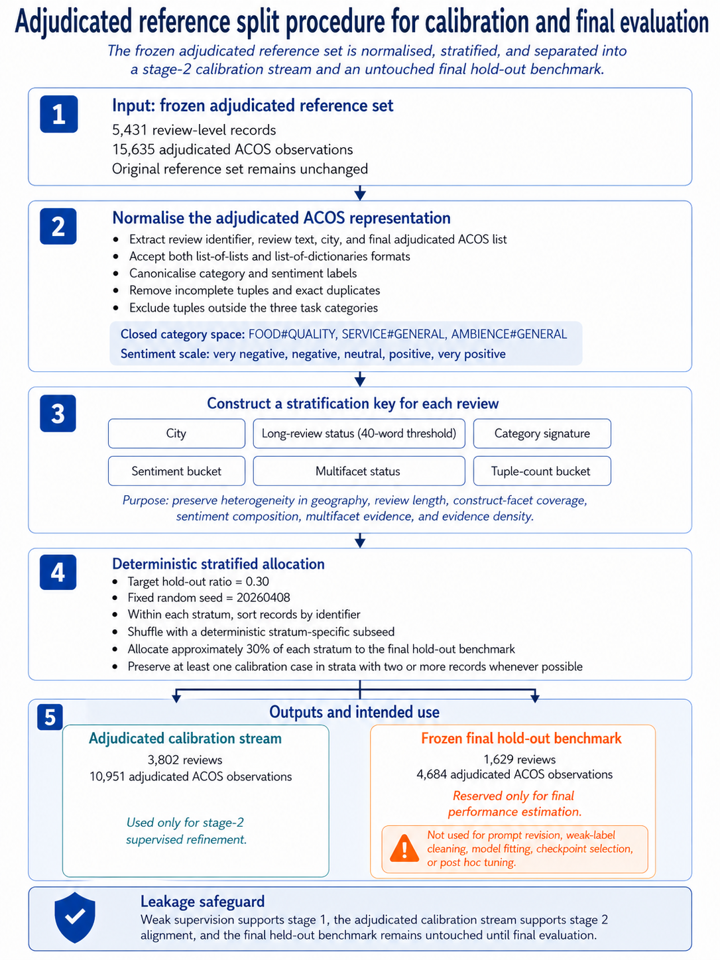
Figure 1 Adjudicated reference split procedure for calibration and final evaluation.

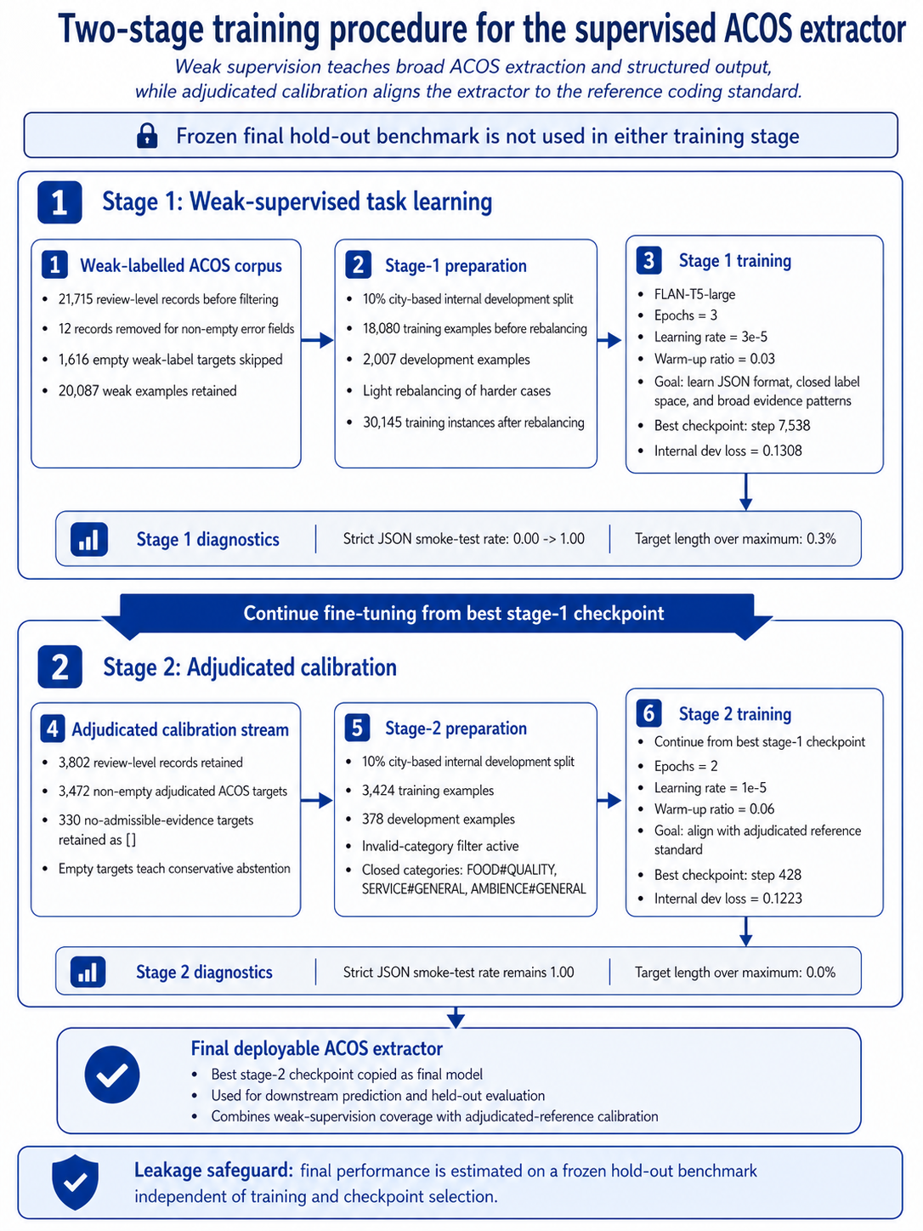
Figure 2 Two-satge training procedure for the supervised ACOS extractor.

Data source | Size | Role in pipeline | Used for model fitting? | Used for model selection? | Used for final performance estimation? | Description
Weak-labelled ACOS corpus | 21,715 review-level records before filtering | Broad weak-supervision stream for stage-1 task learning | Yes, stage 1 | Yes, internal stage-1 development only | No | Kept separate from the adjudicated final hold-out; weak labels are treated as provisional supervision, not ground truth
Adjudicated train split | 3,802 review-level records | High-quality adjudicated calibration stream for stage-2 fine-tuning | Yes, stage 2 | Yes, internal stage-2 development only | No | Derived from the adjudicated reference but separated from the final hold-out before final evaluation
Adjudicated final hold-out | 1,629 review-level records | Frozen benchmark for final evidence-recovery evaluation | No | No | Yes | Never used for prompt refinement, model fitting, checkpoint selection, or post hoc tuning
Final deployed model outputs | Full operational corpus after model selection | Large-scale ACOS evidence recovery for subsequent aggregation | No | No | No | Used only after the extractor had been fixed and evaluated
Table 1 Data separation and leakage safeguards.

Diagnostic | Stage 1: weak-supervised task learning | Stage 2: adjudicated calibration
Supervision stream | Weak-labelled ACOS corpus | Adjudicated calibration stream
Input records before stage-specific filtering | 21,715 review-level records | 3,802 review-level records
Records/examples retained for preparation | 20,087 weak examples | 3,802 adjudicated examples
Non-empty ACOS targets | 20,087 | 3,472
No-admissible-evidence targets retained as [] | No | 330
Internal development split | 10% city-based split | 10% city-based split
Training examples before rebalancing | 18,080 | Not rebalanced
Training instances/examples used for optimisation | 30,145 after rebalancing | 3,424
Development examples | 2,007 | 378
Epochs | 3 | 2
Learning rate | 3.00E-05 | 1.00E-05
Warm-up ratio | 0.03 | 0.06
Model initialisation | FLAN-T5-large | Best stage-1 checkpoint
Checkpoint selection criterion | Lowest internal development loss | Lowest internal development loss
Best checkpoint | Step 7,538 | Step 428
Best internal development loss | 0.1308 | 0.1223
Strict JSON smoke-test rate before stage | 0 | 1
Strict JSON smoke-test rate after stage | 1 | 1
Target length over maximum setting | 0.30% | 0.00%
Table 2 Two-stage training settings and internal diagnostics.

Metric or diagnostic | Matching unit or definition | Main role in the evaluation protocol
Exact tuple micro F1 | Review ID + aspect + category + opinion + sentiment | Strict four-component diagnostic for span fidelity and traceability
Category micro F1 | Review ID + category | Facet-recovery indicator for PFQ, PSQ, and PEQ
Category-sentiment micro F1 | Review ID + category + sentiment | Primary scoring-relevant evidence-recovery metric
Category-opinion micro F1 | Review ID + category + opinion | Local opinion-traceability diagnostic
Sentiment-only micro F1 | Review ID + sentiment | Auxiliary diagnostic of ordinal sentiment recovery
Facet-level category F1 | Category recovery reported separately for PFQ, PSQ, and PEQ | Checks whether facet recovery is balanced across construct dimensions
Facet-level category-sentiment F1 | Category-sentiment recovery reported separately for PFQ, PSQ, and PEQ | Checks whether score-relevant recovery is balanced across construct dimensions
Strict JSON parse rate | Share of raw model outputs directly parseable as JSON | Structured-output stability
Lenient parse rate | Share of outputs parseable after controlled repair or salvage | Operational recoverability
Invalid category share | Share of predicted tuples outside the allowed category space | Closed-label compliance
Duplicate rate before deduplication | Duplicate predicted tuples before normalisation | Looping or repetition diagnostic
Grounded opinion share | Share of predicted opinion phrases found in the review text | Text-grounding diagnostic
Generic opinion share | Share of predicted opinion phrases matching generic templates | Generic-output diagnostic
Count MAE | Mean absolute error between predicted and gold tuple counts per review | Evidence-density diagnostic
Long-review subset diagnostics | Operational diagnostics for reviews above the long-review threshold | Stress test for longer and denser reviews
Table 3 Evaluation metrics and their measurement role.

